



Information pack for the post of Chorister Supervisor



**History**

Southwell Minster is of Saxon origin and was founded as a collegiate church in the tenth century. In 1108 Archbishop Gerard put in process the rebuilding of this Anglo-Saxon church and Southwell Minster was created. The church was elevated to cathedral status with the creation of the Diocese of Southwell in 1884 and is now the Cathedral of Nottinghamshire.

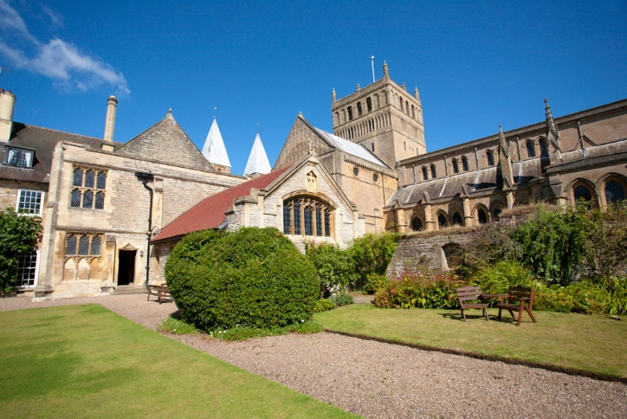The Cathedral stands adjacent to the ruined Archbishop of York’s palace, which had a major renovation in 2013, courtesy of a £1.5 million grant from the Heritage Lottery Fund. The State Chamber of the original palace has remained wonderfully preserved, and acts as a concert venue for the Cathedral. The music department below has undergone a complete renovation, including an addition of two new rehearsal rooms, an Organ Scholar flat and a new music library.

A choir of boys and men has existed at Southwell for over 900 years. Choristers have always been drawn from the Minster School – now a voluntary aided Church of England school complete with a junior school for the education of the younger boys and other musically-gifted children; and which is part of the Choir Schools’ Association. A Girls’ Choir was added in 2005 to enhance the worship at the Cathedral. In 2013, the Cathedral received a major boost with a £20,000 donation to the music programme from the Friends of Cathedral Music.

**The Choirs**

Southwell Minster has a choral tradition stretching back over 900 years and currently comprises Boy Choristers, Girl Choristers, Lay Clerks – six daily singers and six Auxiliary Lay Clerks, and the Minster Chorale. Between them, the Boy and Girl Choristers rehearse and sing services on six days of the week, including Evensong on their own on Monday and Tuesday. The Lay Clerks sing with the Choristers from Thursday until Sunday, and for Feast Days and Holy Days at other times. The Cathedral Choir’s repertoire is large and aims to include the best of all eras, from large-scale anthems of Byrd and Palestrina through to Gabriel Jackson and MacMillan with much in between. They regularly broadcast and record, and foreign tours are undertaken frequently.

The Rector Chori is responsible for the Boy Choristers, and the Assistant Director of Music is responsible for the Girl Choristers – the Organ Scholar plays for services as required, for any combination of Choristers and Lay Clerks, and for the Minster Chorale. The Minster Chorale, the Cathedral’s voluntary choir, is also run by the Assistant Director of Music, and sings at Cathedral liturgies as necessary, complementing the Cathedral Choir’s duties. All the members of the music foundation form a singularly warm and welcoming group.

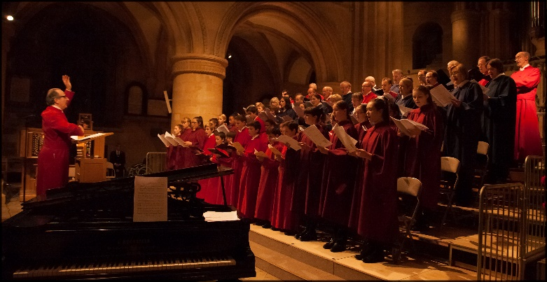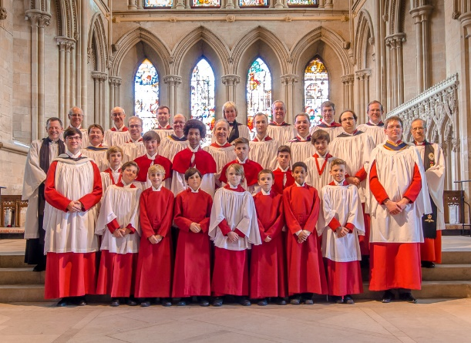

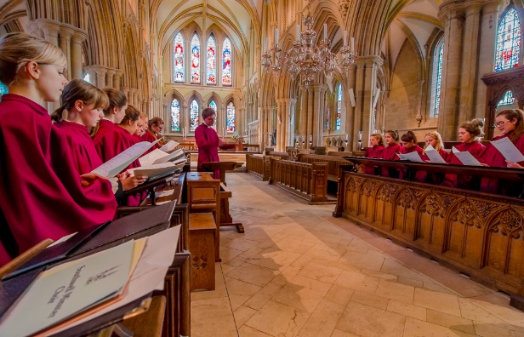

**The Cathedral Choir of**

**Southwell Minster**

***Chorister Supervisor***

The Chapter of Southwell Minster are looking to appoint a committed individual to supervise the boy and girl choristers, and to work with Cathedral staff, the Minster School and other stakeholders in ensuring the safety, wellbeing and flourishing of the choristers.

Music in a Cathedral context is an integral part of worship and mission and the music department is committed to promoting the Minster as a centre for excellence in liturgy and music.

Working under the direction of the Rector Chori and Assistant Director of Music, the Chorister Supervisor will:

1. Attend rehearsals, services and concerts involving choristers (boys and girls). During these events, the supervisor should take the register, and be available to supervise toilet visits, illness etc. At the end of any event the supervisor should 'sign out' each chorister to the appropriate adult(s).
2. Take a full part in running chorister club on Tuesdays, Thursdays and Fridays, in collaboration with the Organ Scholar. This would include arranging tea for them with the Refectory.
3. Walk children from school (with the organ scholar) each evening.
4. Keep to hand appropriate records of the choristers' health and special needs and to be fully involved in discussions relating to any special requirements.
5. Keep appropriate members of staff notified of any concerns regarding specific children or health and safety in general (with the guidance of the Cathedral or Diocesan Safeguarding Officer if appropriate).
6. Keep up-to-date with relevant first-aid training and ensure first-aid kits are present and up-to-date in all rehearsal spaces.
7. Ensure the Cathedral's safeguarding policy is adhered to in all the above, and attend regular training sessions according to the direction of the Dean and Cathedral Safeguarding Officer
8. Have completed both Minster School and Cathedral DBS checks
9. Liaise with the Minster School regarding illness or absence of choristers
10. Keep to hand a list of emergency phone numbers for choristers
11. Maintaining discipline and attending to the pastoral needs of the choristers, together with the Rector Chori & Assistant Director of Music.
12. Take part in choir tours, which are arranged from time to time. As well as taking part in the tour itself, the Chorister Supervisor will play an important role in the organisation of tours as pertaining to the choristers.
13. Attend regular meetings with the Rector Chori and Assistant Director of Music.
14. Attend the termly chorister parents’ meetings.
15. Promote equal opportunities and diversity in the work of the music department

Although the choir timetable includes both morning and afternoon commitments, it is highly possible that the Chorister Supervisor role could be shared. Priority in this instance will be given to the afternoon commitments, as these are the ones where staffing is most critical.

A normal weekly timetable would look as follows: [OS = Organ Scholar AP = Archbishop's Palace]

MONDAY

0750 Take register as choristers arrive, and sit in on rehearsal [Song School]

0840 Walk the boys - and juniors - to school, with the OS

1514 Walk the younger girls (years 6-9) from School to the AP, as required

1545 Take register, and sit in on girls' rehearsal [Peace Room], then Evensong ('signing them out' at 1815)

TUESDAY

0750 Take register as choristers arrive, and sit in on rehearsal [Song School]

0840 Walk the boys - and Juniors - to school, with the OS

1514 Take register, and supervise Chorister Club with another member of the music dept. [Minster School]

1600 Walk boys to AP, then sit in on rehearsal and Evensong ('signing them out' at 1815)

WEDNESDAY

Normally no choir duties

THURSDAY

0750 Take register as choristers arrive, and sit in on rehearsal [Song School]

0840 Walk the boys - and Juniors - to school, with the OS

1514 Take register, and supervise Chorister Club with another member of the music dept. [Minster School]

1600 Walk boys to AP, then sit in on rehearsal and Evensong, finishing at 1815

1820 Boys continue for a full rehearsal, normally until 1900.

FRIDAY

0750 Take register as choristers arrive, and sit in on rehearsal [Song School]

0840 Walk the boys - and Juniors - to school, with the OS

1514 Take register, and supervise Chorister Club with another member of the music dept. [Minster School]

1600 Walk boys to AP, then sit in on rehearsal and Evensong ('signing them out' at 1815)

SATURDAY

1550 Take register as choristers arrive, and sit in on rehearsal [Song School]

1700 Sit in on full rehearsal and Evensong [Minster] ('signing them out' at 1815)

SUNDAY

Sit in on rehearsals for the boys and girls as required each week. Sunday schedules will (in general) be one of the following, but are subject to the most change:

Week 1: 0830-1230 (morning services) and 1445-1630 (Evensong).

Week 2: 1000-1230 (morning services) and 1445-1630 (Evensong).

A more detailed schedule is produced at the end of each term for the subsequent term’s commitments. This will include all timings, and will show where there are no commitments. Changes to the published schedule are avoided, however may occasionally be necessary – these will be notified as soon as possible.

The successful applicant will

i. have a proven ability to work with children of ages 7-18

ii. have relevant first aid qualifications or willingness to receive training

iii. be committed to working to best practice in the safeguarding of children

iv. have an empathy with the aims of the Church of England, and ideally the Anglican choral tradition

v. have high expectations of achievement and behaviour from the children and themselves

vi. be effective in managing the behaviour of children

vii. be flexible and a team player

viii. have a caring nature and a genuine interest in the welfare of children

ix. have the ability to inspire confidence in parents and colleagues

x. be committed and loyal, with a sense of humour

xi. be able to work to deadlines and under pressure

xii have reliable access to transport (preferably their own)

**Statements**

|  |  |
| --- | --- |
| **Equality**  Southwell Minster recognises that discrimination and  victimisation are unacceptable and that it is in the interests of the Minster and its employees to utilise the skills of the total workforce. It is the aim of the Minster to ensure that no employee or job  applicant to the Minster receives less favourable treatment (either directly or indirectly) in recruitment  or employment on grounds of age, disability, gender/ gender reassignment, marriage/civil partnership, pregnancy/maternity, race, religion or belief, sex or  sexual orientation (defined as the protected  characteristics in the Equality Act 2010). | **Safeguarding**  Southwell Minster is committed to:  • safeguarding, caring for and nurturing children and young people in the Minster and community.  • safeguarding and caring for vulnerable adults in the Minster and community.  • informing those involved with children and vulnerable adults in our church of the behaviour expected of them.  • explaining the procedure for background checks of those involved with children and vulnerable adults in the Minster  • protecting adult members of the church from malicious or false accusations of abuse. |

**Terms of Appointment**

**Line Manager**

The Chorister Supervisor is responsible to the Rector Chori and the Assistant Director of Music, and through them to the Dean.

**Salary**

The hourly rate for this post is £8.75, paid monthly in arrears in regular amounts every month irrespective of choir activity.

**Working hours**

The Cathedral Choir schedule follows closely the Minster School term dates, with extension into Christmas (including Christmas Day) and Easter (including Easter Day). The total number of working weeks is 39.

**Holiday**

Holiday entitlement will coincide with School holidays. The post holder may be asked to work on a public holidays and will be entitled to time off in lieu. The holiday year begins on the 1st January.

**Pension**

The Cathedral operates a pension scheme in respect of your employment. Employees are entitled to join the stakeholder scheme. Chapter pay 8.5% of salary into the scheme on behalf of employees. Further details are available from the Finance Officer.

**Tours**

Tours normally take place during school holidays, and will be negotiated separately, and the choir sings for the final event of the Southwell Music Festival on August Bank Holiday Monday.

**Probation**

The appointment is subject to the successful completion of a probationary period of 3 months during which employment can be terminated by one week’s notice by either party.

**Applications**

In order to apply for this position, please send a completed Application Form Adele Poulson, Cathedral Administrator at [administrator@southwellminster.org.uk](mailto:administrator@southwellminster.org.uk) or The Minster Centre, Church Street, Southwell, NG25 0HD.

The closing date will remain open until the vacancy is filled.